How to do Texture Blending with Vertex Colors in 3D Studio Max
This tutorial will help provide you with the information necessary to apply a texture blending technique to your models in Jupiter. This is a great method for doing large areas where you would need to blend two different textures together to break up tiling or to add variety.

Step 1:
Make a new material and place a Mix map in the Diffuse slot.
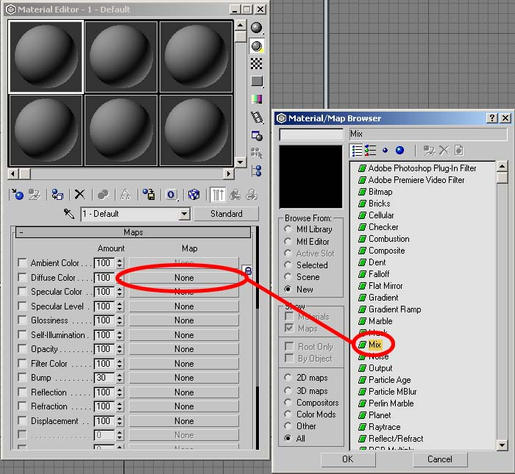

Step 2:
Put two different textures in the Mix map slots.
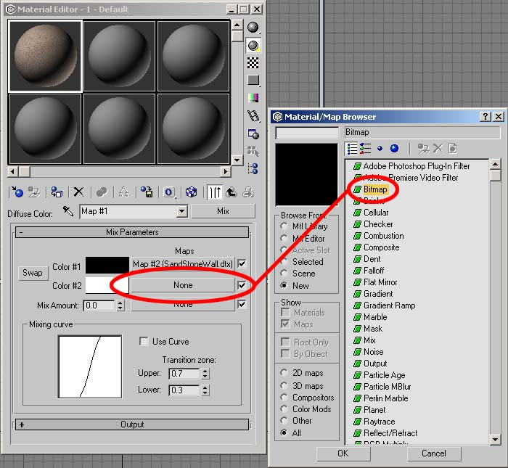

Step 3:
Put an Output map in the Mix Amount slot, and then check Invert (see next image).
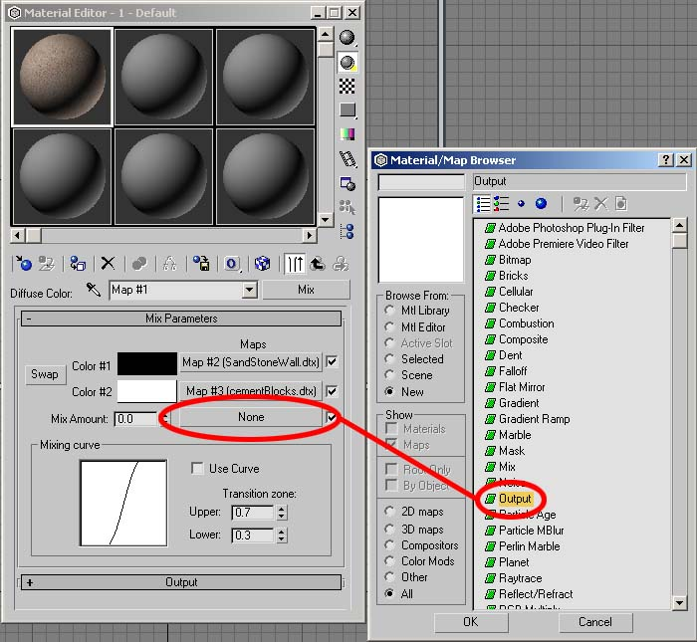

Step 4:
Put a Vertex Color map in the Output Map slot.
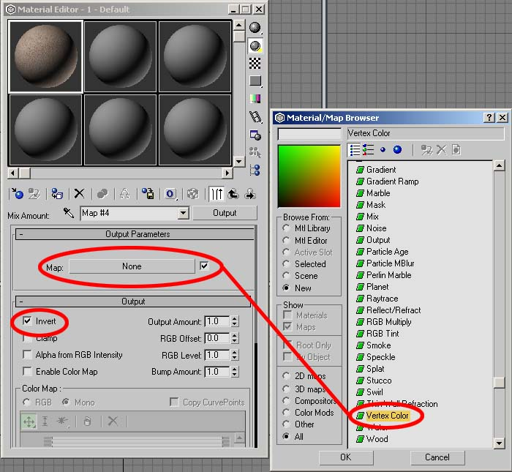

Step 5:
Add a VertexPaint modifier to your mesh and use a Black, White, or a Grayscale color only.
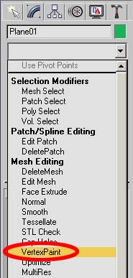

Step 6:
Use the paintbrush tool to color the verticies and assign the blended texture information. (You may have to click the VertexColor button to see the brush feedback.)
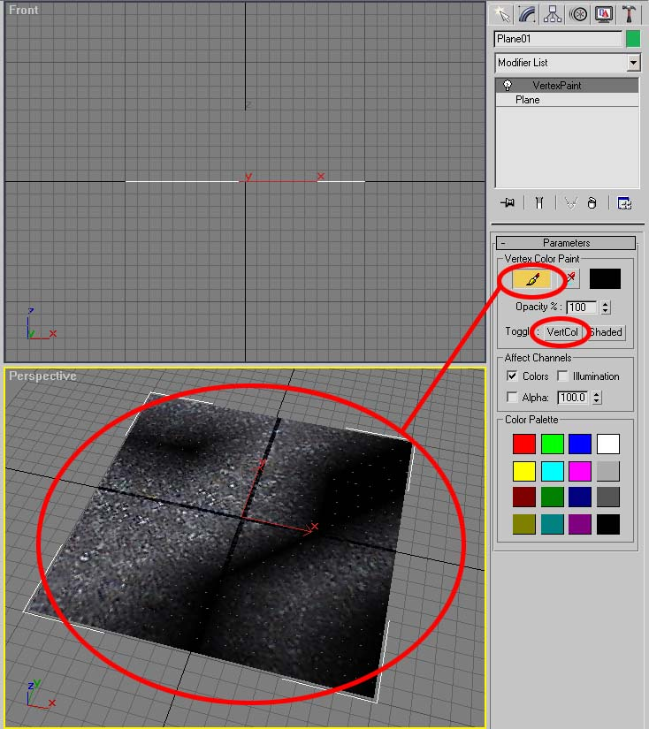

So, by painting different shades of gray from black to white, you actually control the amount of blending between the two textures. In this case, assume that the verticies all start off white (which shows "SandStoneWall.dtx"), so if you paint black onto the mesh, it will show the texture in slot #2, which is "cementBlocks.dtx".
The effect that we are trying to accomplish should look something like this:
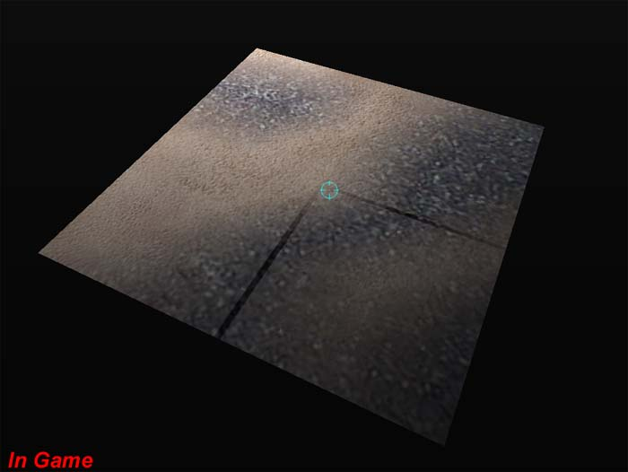
©2003 Touchdown Entertainment, Inc. All rights reserved. Legal

